Array City Trip
By: Paulette Vargas, Teresa Washington, William Washington, and Steven Winters

It was 6:00 A.M. on Sunday morning when 8-year-old Johnny woke up excited to start his day. This was very odd behavior for Johnny. Johnny typically does not wake up on a Sunday until much later. So, why was today special? Today was the day that Johnny and his family were to travel to Array City for the annual 4th of July carnival and firework show. Johnny had been waiting for this day for weeks. Not being able to contain himself, he rushed into his parent’s room and excitedly screamed “I am ready...I am ready... let’s go… let’s go to Array City!” Johnny’s parents realized that the carnival activities did not take place until later in the day, but also realized that Johnny was too excited to let them just lie in bed. So, Johnny’s parents woke up to start their 4th of July day. Johnny’s dad made Johnny and his mother breakfast. After breakfast, Johnny and his father washed the dishes and cleaned the kitchen, while Johnny’s mother loaded the family car with the necessities for the trip. Once the car was loaded, Johnny and his parents were off to Array City.

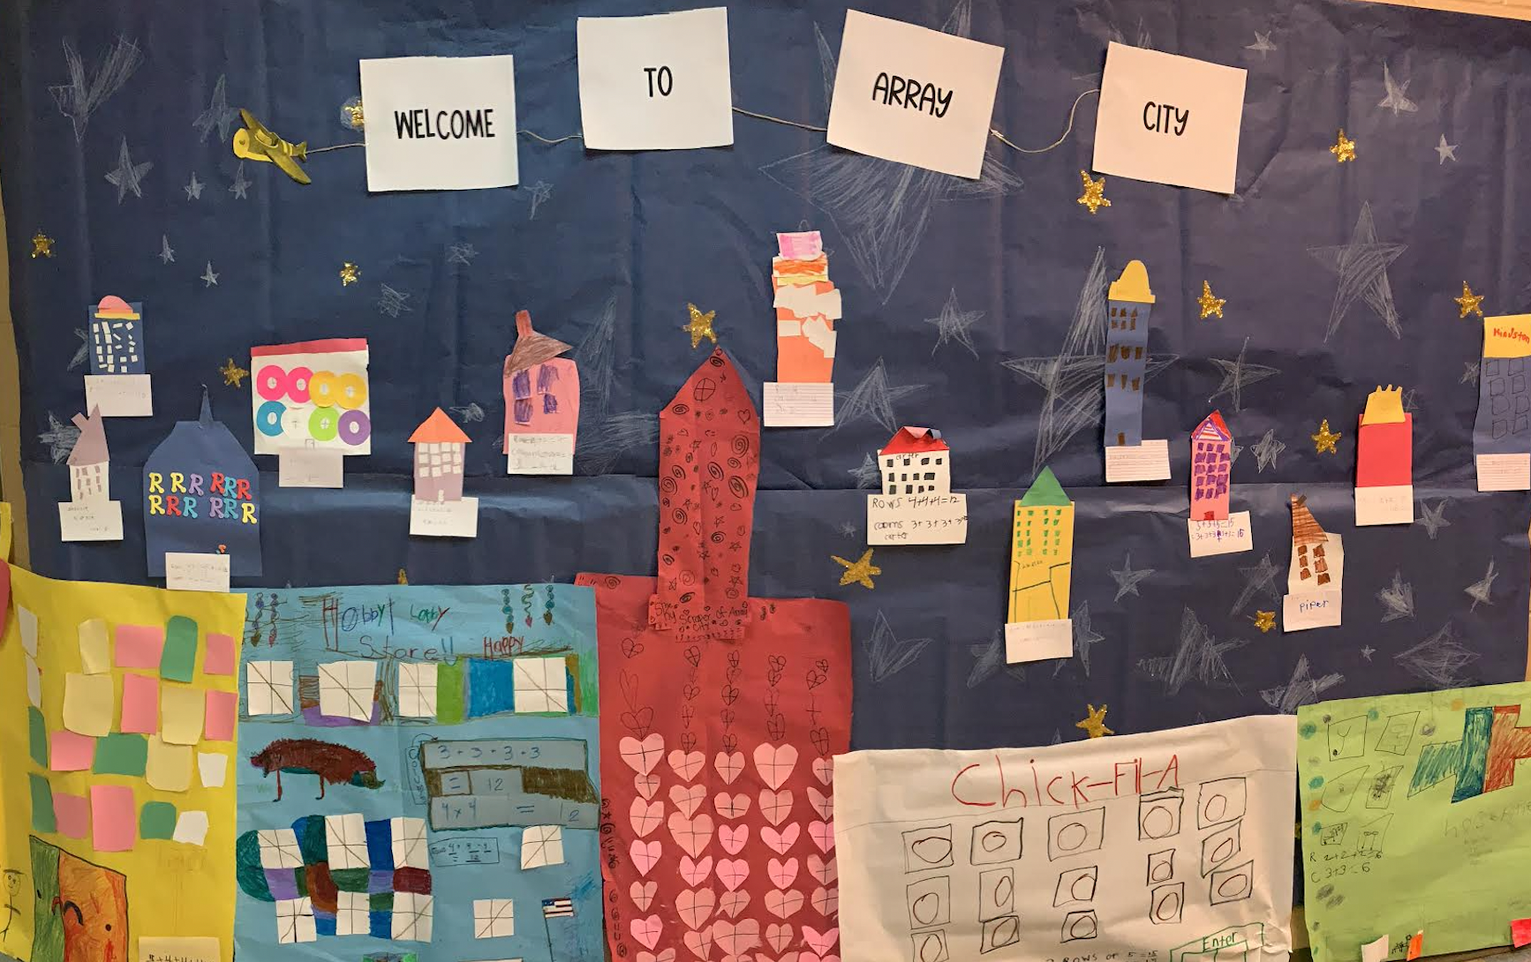
Johnny and his parents arrived at Array City at 12pm and were all ready to make their way to the carnival, so they could get some carnival food, ride some rides, and play some games. Johnny was the most excited. However, when they arrived they were not able to get parking near the carnival and had to park far away. In fact, you could not even see the carnival or hear the rides. “How will we ever find the carnival? '' said Johnny. “We can use the city map we printed from the event website”, said Johnny’s father. Looking at the map both Johnny and his dad saw that each city building was numbered by the number of windows the building had on each side, and the carnival was between two buildings that had the same number of windows - 20 windows on each side to be exact. To get to the street that the carnival was on, they determined that Johnny and his family would need to determine their starting point first. Since each building on the map was numbered by the number of windows on the side of the building all they would have to do would be to count the number of windows on the buildings around them and match it to the map. Johnny took a look around at the buildings and noticed that there were four buildings and each building had windows that went up and down and also windows that went across from left to right or right to left. Johnny asked his mother why the building had lines of windows that went up and down and also across. “The windows that go from side to side are called rows and the windows that go up and down are called columns, said Johnny’s mother. “Do you see how each row has the same number of windows as all of the other rows, and that number of windows in each column are also the same number of windows in the other columns, '' Johnny's dad said. Johnny, looked at one of the rows and columns of one of the buildings and replied, “Yes I do see where the windows are the same in each row and each column”. That is called an array Johnny, the dad said. Johnny quickly replied, “ Is that why they call it Array City”. And, then Johnny’s dad replied “yes it is, Johnny.” Johnny then realized that since the rows and columns contained the same number of windows, the windows could be counted in each row or column and then we could add the rows and columns together to get the total number of windows in the array. By doing this, Johnny quickly counted the number on each building around him and then matched it to the map. Then the family was able to navigate through the city by adding the rows or columns in each building's array of windows to identify the buildings on the map and to successfully locate the carnival.

